Year 6 Camp Gear List
Camp Ngaruawahia 10th- 13th August 2020
Please name all gear
Please note our trip has changed to a winter camp. Ngaruawahia can be foggy
and damp so more warm clothes will be required. This camp list has changed.

Camping Equipment
Day bag (backpack) containing morning tea, cut lunch and large bottle of water for first day. (This travels with you inside the bus on the first day. Bring a plastic bag if you get bus sick.)

Medication
Medication with labelled instructions (if required). Give to Doctor Ranchhod before departure
from BBPS.

Food
Named container of home baking, to be shared e.g. hand food such as cookies, brownies (Please make a card of the ingredients, due to some children having severe allergies. No nuts please.)
Small bag of fruit to be shared during camp for morning and afternoon tea. Please do not cut this up.

Sleeping gear
(This can be packed in a big black rubbish sack. Use two as they rip. This will be packed on the
bus separately. Make sure you name this bag by putting masking tape on and writing your
name
on this.)
Sleeping bag and at least 1 blanket (Send more blankets, if sleeping bag is not a warm winter weight sleeping bag)
1 single fitted sheet, to stop the sleeping bag sliding off the bed
Pillow
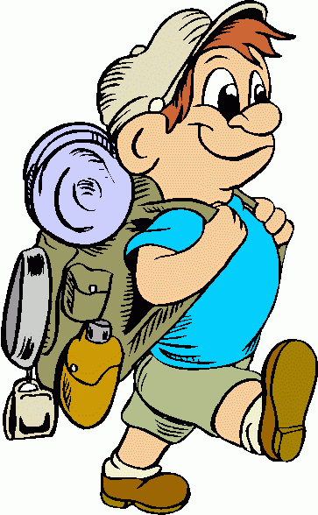
Clothing in a separate large carry bag
5 pair of socks
Underwear, several sets (4 days) Everyone will need two
sets some days, especially if we get rain.
2 pairs shorts
4 pairs long trousers / track pants
4 light tops - t shirts
Two sets of polypropylene tops are recommended
3 warm jerseys or sweatshirts (fleecy)
Pyjamas (warm ones)
Togs (these may not be used but pack anyway for mudslide)
Jandals for around camp
Old sneakers/trainers - that can get wet or dirty(not your best
pair)
Gumboots (if you have a pair)
Sun hat
Woolly hat/beanie
Parka or raincoat (WATERPROOF!)

Other
Toilet gear (soap, toothbrush, toothpaste, hairbrush, etc)
Towel x 3
Torch (this will be used for night activities)
Handkerchiefs/tissues
Mosquito repellent- The mosquitos in the Waikato are monsters!
Book to read
Card game/ small travel game
large plastic bag (to put wet clothing into)
A sense of humour !!!

Notes:
We will have a camp concert on the last night so be thinking about a short skit your group could do. There are normally about ten students in a team so find a skit with lots of characters. You may want to bring a couple of props/script, but nothing too big.

Remember to NAME ALL GEAR

IMPORTANT !
YOU MAY NOT TAKE JEWELLERY, RADIOS, ELECTRONIC GAMES, IPADS, CELLPHONES,
PRIVATE FOOD, SWEETS, GUM, MATCHES, LIGHTERS, NON WATERPROOF WATCHES, MONEY

